PROJECT NAME : 2026 FIFA World Cup Database Management System
DATABASE NAME : WorldCupDB

MEMBER 1
Ozan Can Topbaşlı - 2203021050

MEMBER 2
Serranur Taşcı - 2203021074

1. Project Purpose

- The purpose of this project is to design and implement a database management system for a Football World Cup Organization.

- The database system stores and manages information related to teams, players, groups, stadiums, referees, matches, goals, cards, and tournament standings.

- This project aims to demonstrate the use of relational database concepts such as primary keys, foreign keys, table relationships, and SQL queries in a real-world tournament scenario.

- The system allows users to organize match information, track tournament results, display standings, and retrieve important tournament data through SQL queries.

2. What the Database Does
The World Cup database system manages all major tournament operations.

The database stores:
- Team information
- Player information
- Group information
- Stadium information
- Match schedules and results
- Referee information
- Goals and cards
- Tournament standings

The system enables users to:
- View all teams and players
- Display match results
- Track goals and cards
- List tournament standings
- View knockout stage matches
- Display the final match and champion team

3. Member Responsibilities
The project was developed by two team members.

Ozan was responsible for:
- Designing and implementing the Groups table
- Designing and implementing the Teams table
- Designing and implementing the Players table
- Designing and implementing the Stadiums table
- Inserting base tournament data
- Organizing database structure and IDs
- Final database integration
Serra was responsible for:
- Designing and implementing the Referees table
- Designing and implementing the Matches table
- Designing and implementing the Goals table
- Designing and implementing the Cards table
- Designing and implementing the Standings table
- Inserting match and tournament result data
- Preparing SQL queries and match simulations

Both members worked together on:
- Testing the database
- Query verification
- Preparing the project report
- Preparing the project presentation

QUERİES SCREEN PHOTO

- This query lists all teams, their managers, and the group information they belong to.

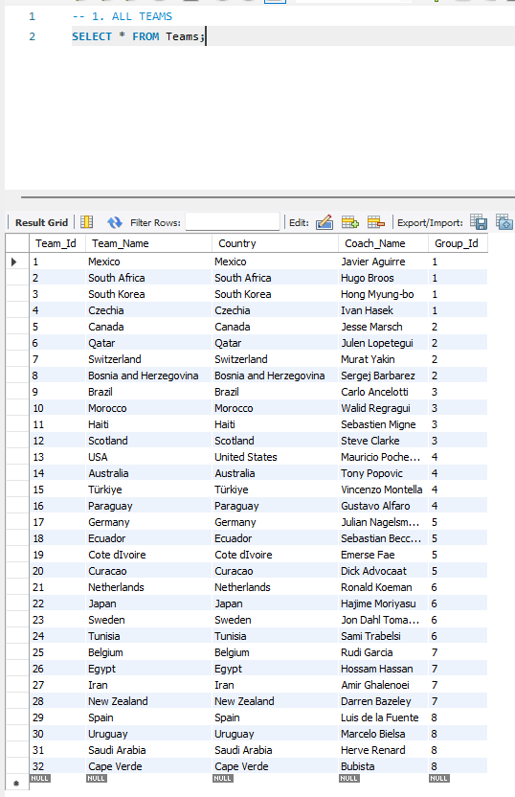

- This query lists all players, including their teams, jersey numbers, ages, and playing positions.

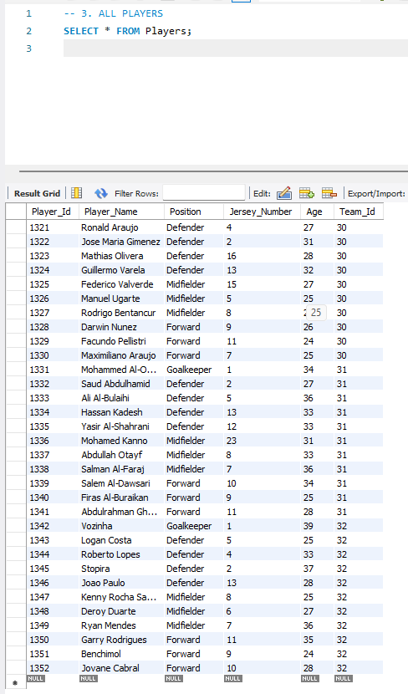
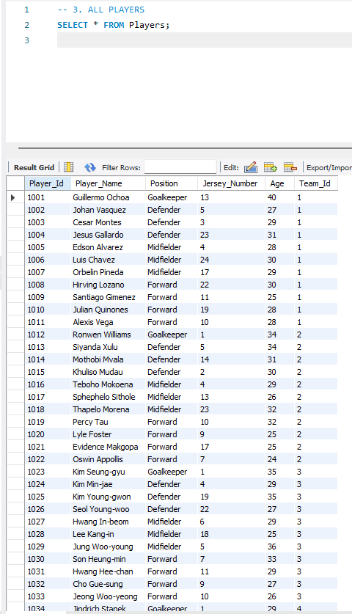

- This query lists all stadiums, their capacities, and the cities they are located in.
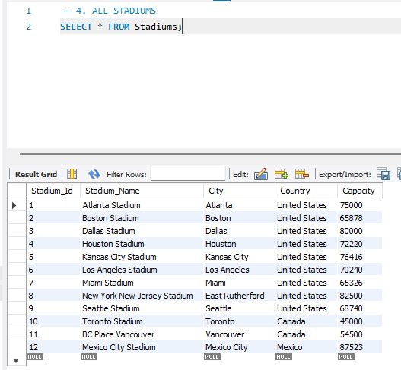

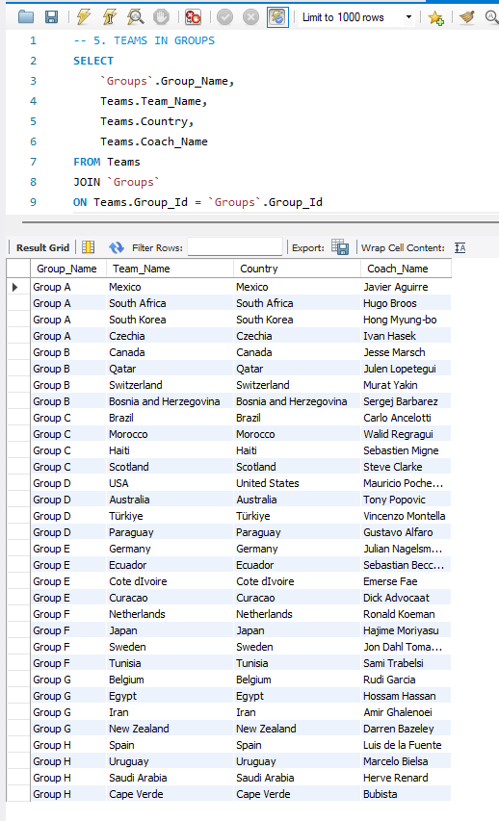
- This query shows which groups all the teams are in in the tournament.

- This query lists general information about all group matches, including score, time, referee, and match details.

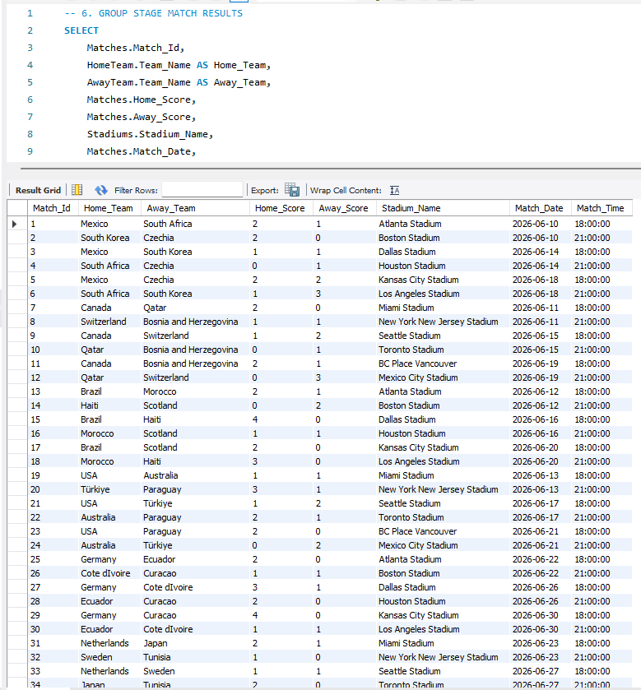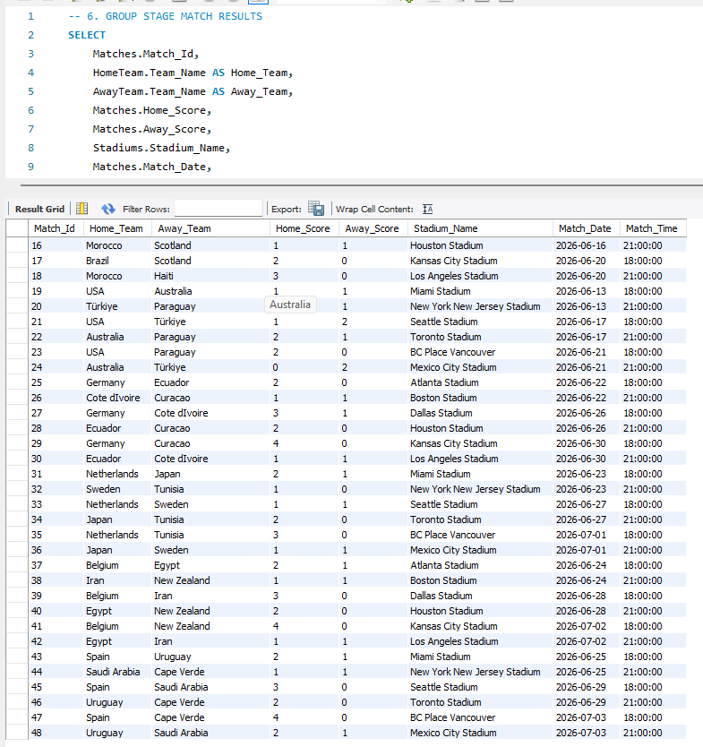

- This query lists the teams that finished first in their groups after the group matches were completed.

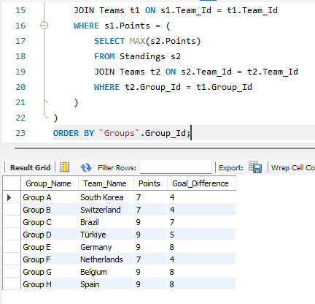

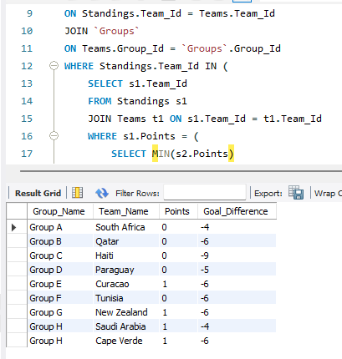
- This query lists the teams that finished last in their groups and were eliminated from the tournament after the group stage matches were completed.

- This query lists the teams that successfully completed the group stages and advanced to the round of 16.

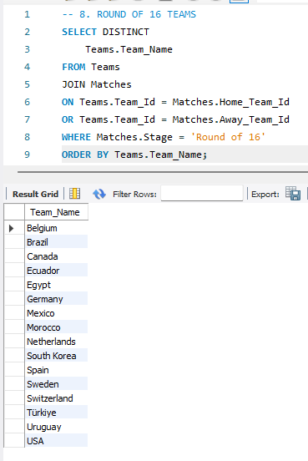

- This query lists the scores, dates, and stadiums for the matches played in the round of 16.

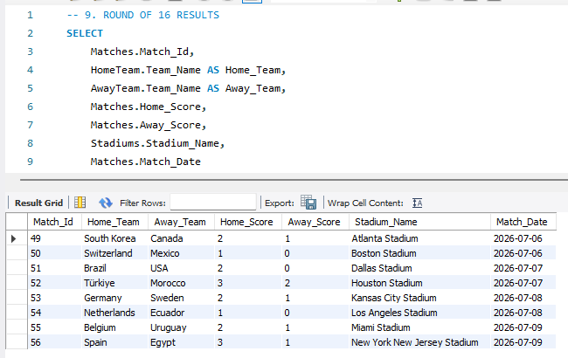

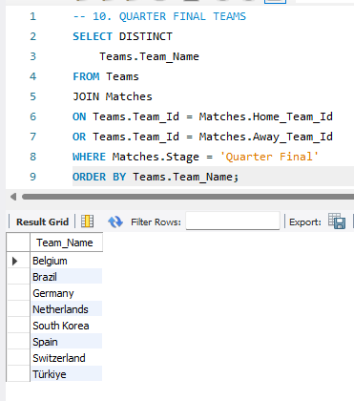
- This query lists the teams that successfully completed the round of 16 and qualified for the quarterfinals.

- This query lists the scores, times, and stadium information for the quarter-final matches.

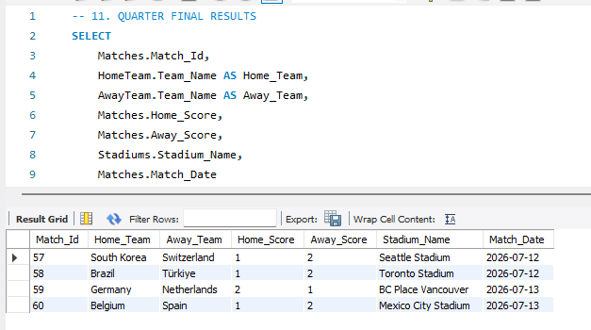

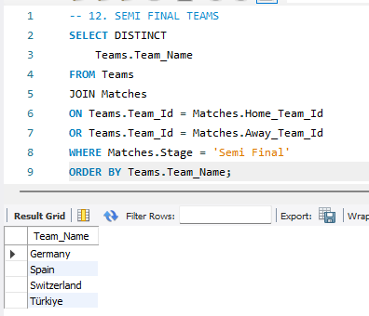
- This query lists the teams that successfully advanced from the quarter-final matches and qualified for the semi-finals.

- This query lists the scores, times, and stadium information for the semi-final matches.
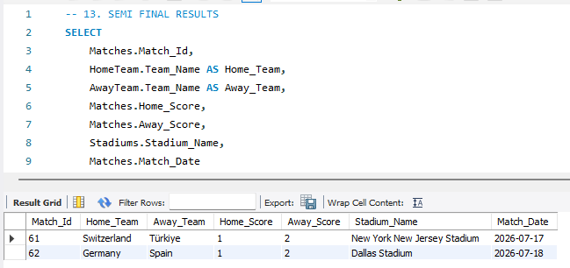

- This query lists all the details of the final match. Our hearts are with our national team in this year's tournament, and we hope for such a great result.
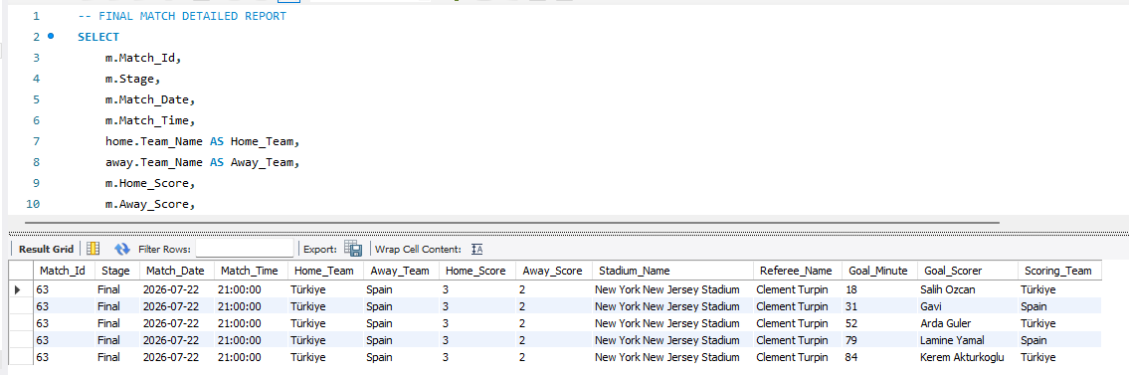

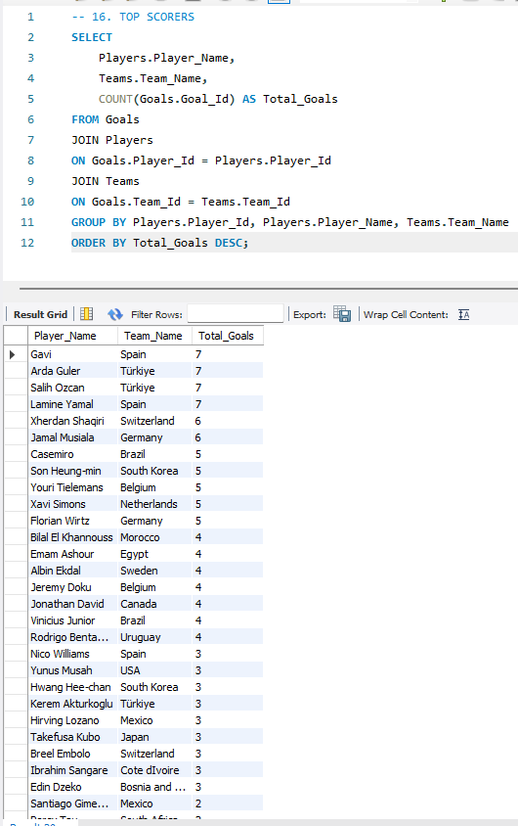
- This query lists the players who were in contention for the top scorer title throughout the tournament, along with their information.

Database Relationship Explanation
This EER diagram shows the relational structure of our World Cup Database Management System project. The system was designed to store and manage information about teams, players, matches, stadiums, referees, goals, cards, groups, and standings.
The database uses primary keys and foreign keys to create connections between the tables. These relationships help keep the data organized and prevent data duplication.

Main Tables and Relationships

1. Groups and Teams
Each team belongs to one group in the tournament.
- The groups table stores the group information such as Group A, Group B, etc.
- The teams table stores team details.
- Group_Id in the teams table is connected to Group_Id in the groups table.
This relationship is a one-to-many relationship because one group can contain many teams.

2. Teams and Players
Each player belongs to one team.
- The players table stores player information such as name, position, jersey number, and age.
- Team_Id in the players table connects players to their teams.
This is also a one-to-many relationship because one team can have many players.

3. Matches and Teams
The matches table stores all match information.
Each match contains:
- home team
- away team
- stadium
- referee
- score
- stage information
Home_Team_Id and Away_Team_Id are connected to the teams table.
This relationship allows the system to track which teams played against each other.

4. Matches and Stadiums
Every match is played in one stadium.
- The stadiums table stores stadium information such as stadium name, city, country, and capacity.
- Stadium_Id in the matches table connects matches to stadiums.
One stadium can host many matches.

5. Matches and Referees
Each match is controlled by one referee.
- The referees table stores referee information.
- Referee_Id in the matches table connects the referee to the match.
One referee can manage multiple matches.

6. Goals Table
The goals table stores all scored goals in the tournament.
Each goal record contains:
- the player who scored
- the team
- the match
- goal minute
This table is connected to:
- players
- teams
- matches
These relationships help determine:
- top scorers
- match goal details
- team scoring statistics

7. Cards Table
The cards table stores yellow and red card information.
Each record includes:
- player
- team
- match
- card type
- card minute
This table is connected to:
- players
- teams
- matches
This allows the system to track disciplinary actions during matches.

8. Standings Table
The standings table stores tournament statistics for teams.
The table includes:
- played matches
- wins
- draws
- losses
- goals for
- goals against
- goal difference
- points
Team_Id connects standings data to the related team.
This table is used to determine:
- group winners
- rankings
- teams advancing to knockout stages

General System Structure
The database was designed using a relational model. All tables are connected logically using foreign key relationships. This structure makes the system more organized, scalable, and easier to manage.
The project can perform many operations such as:
- listing players and teams
- showing match results
- calculating standings
- finding top scorers
- displaying cards and disciplinary records
- showing knockout stage progress
Overall, the database provides a complete World Cup tournament management system using MySQL relational database principles.

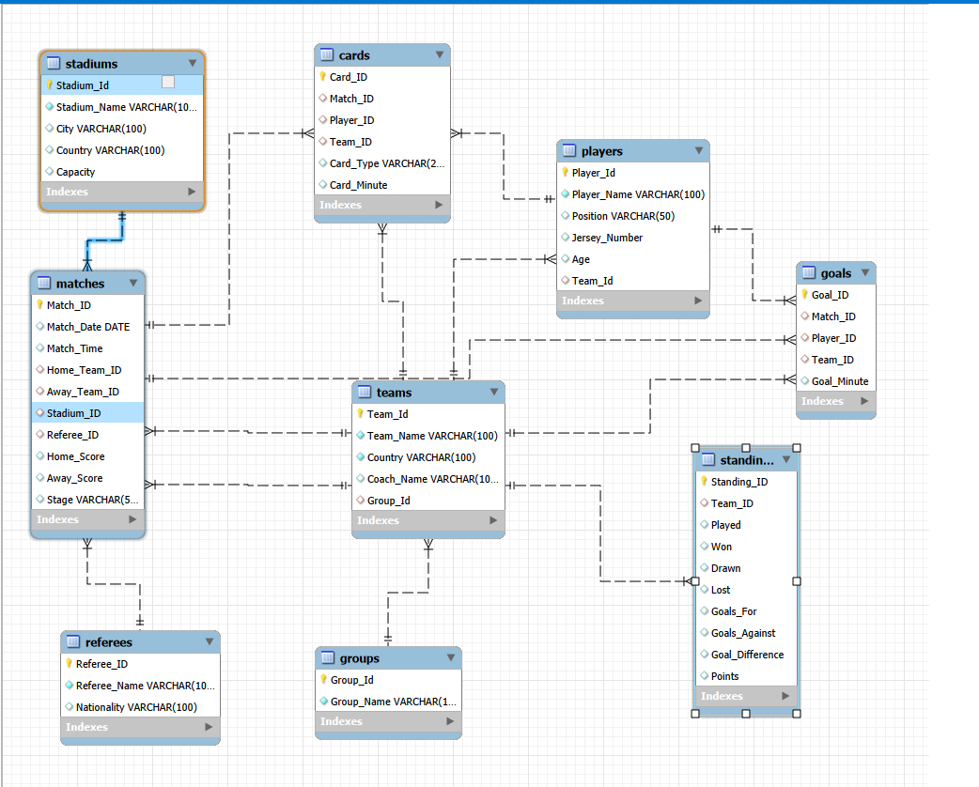

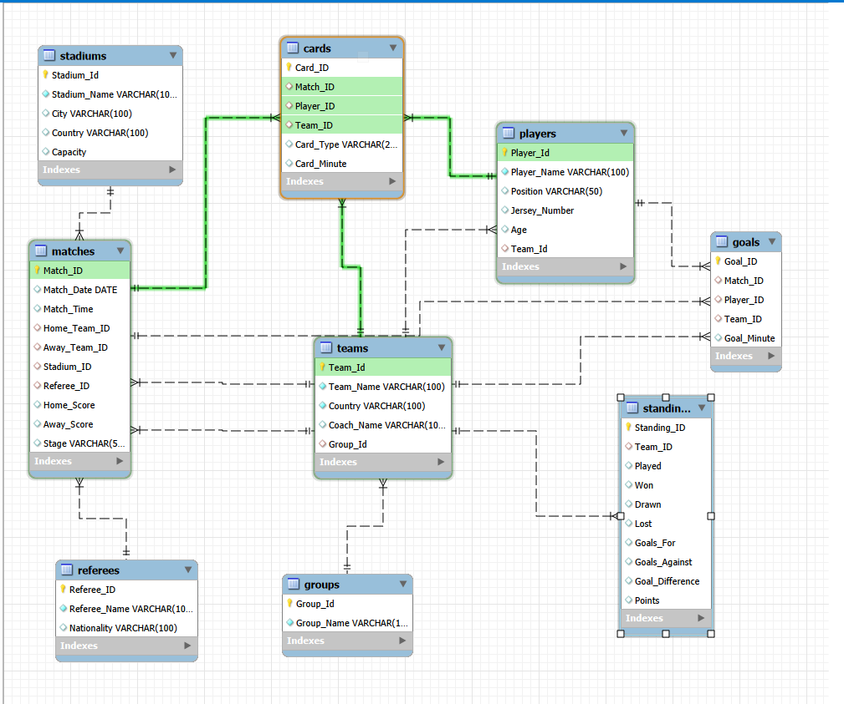

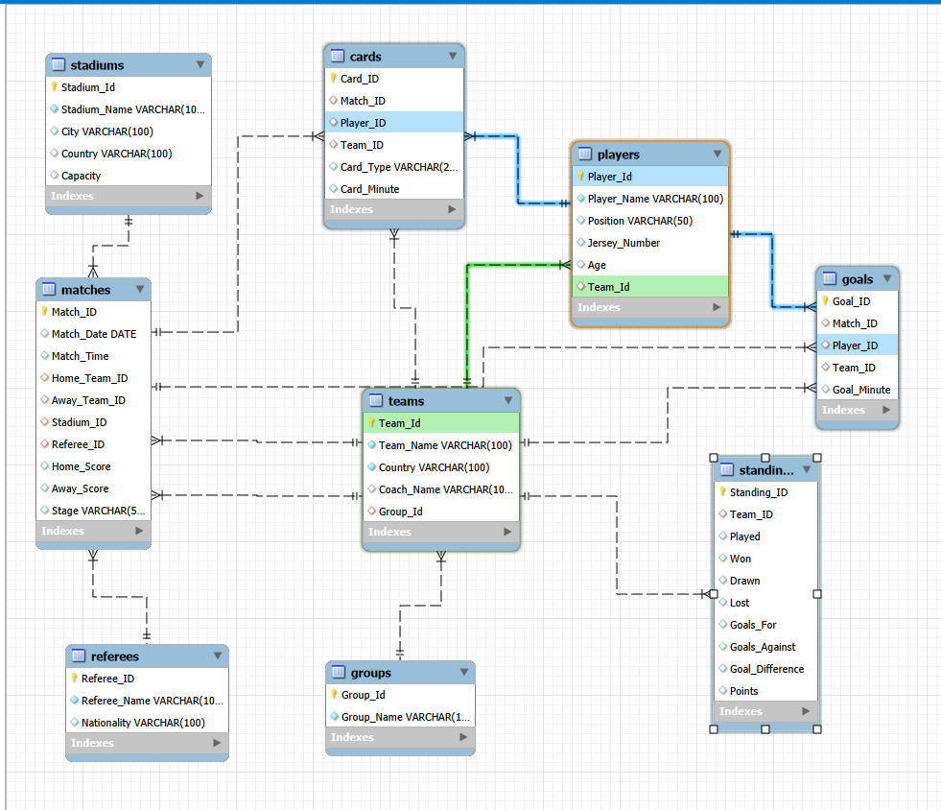

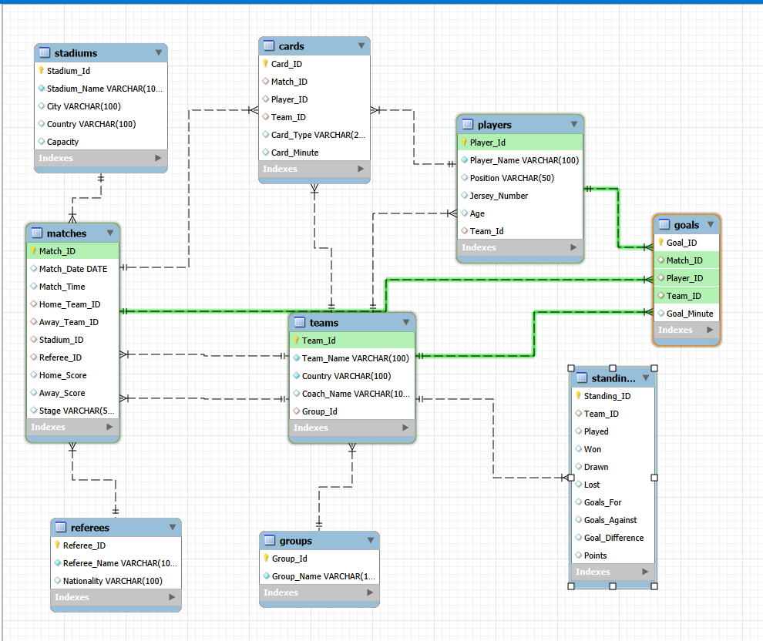

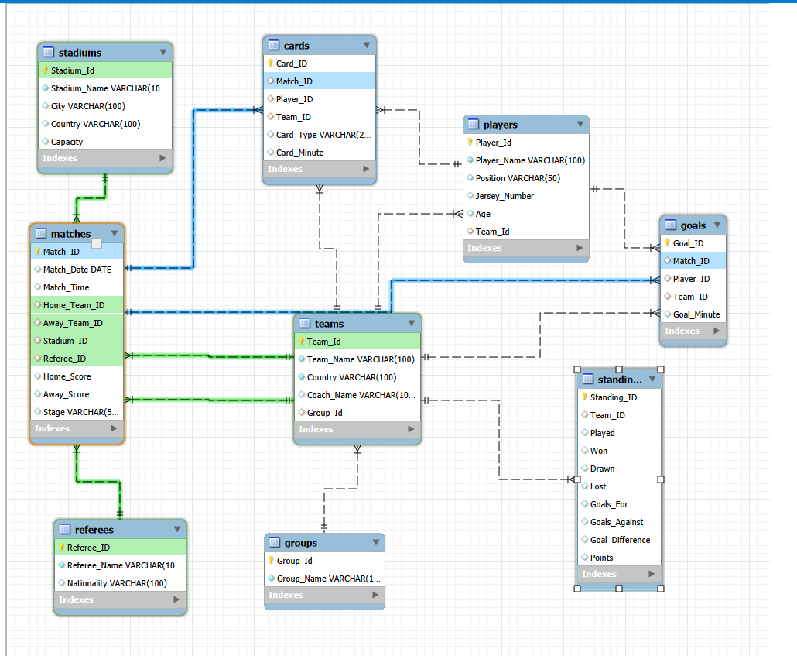

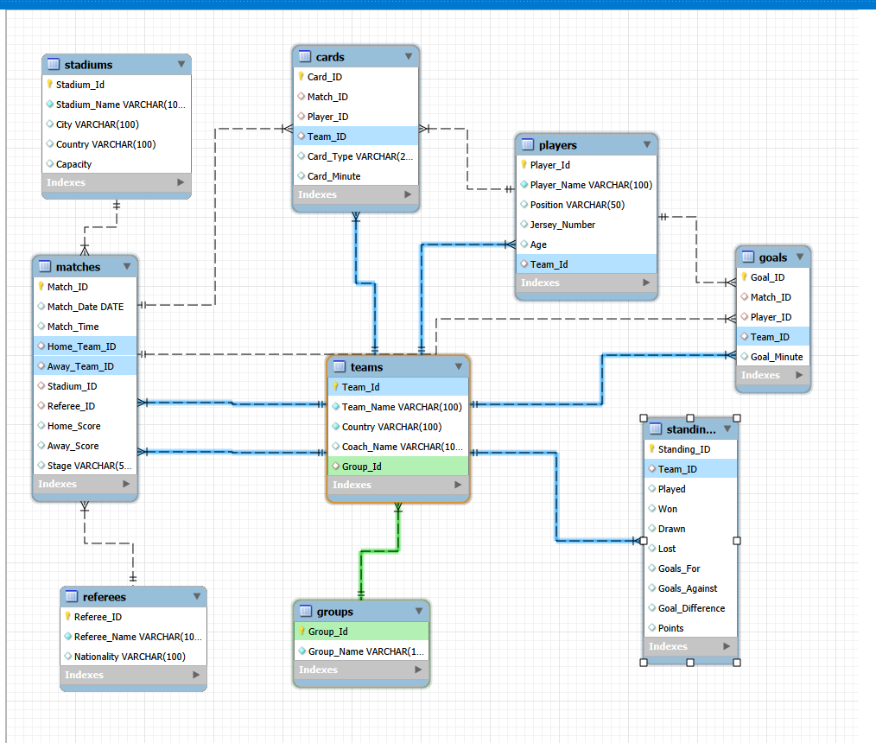

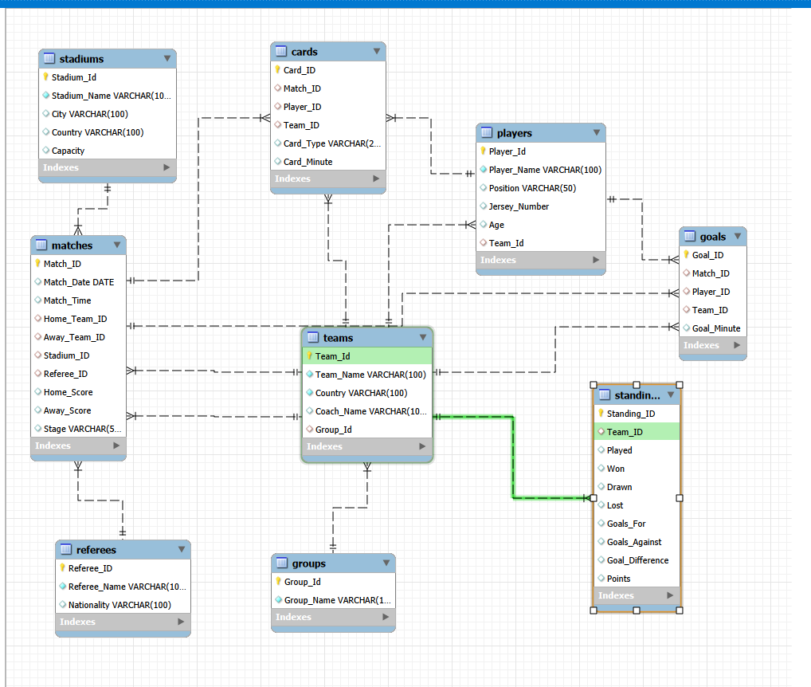

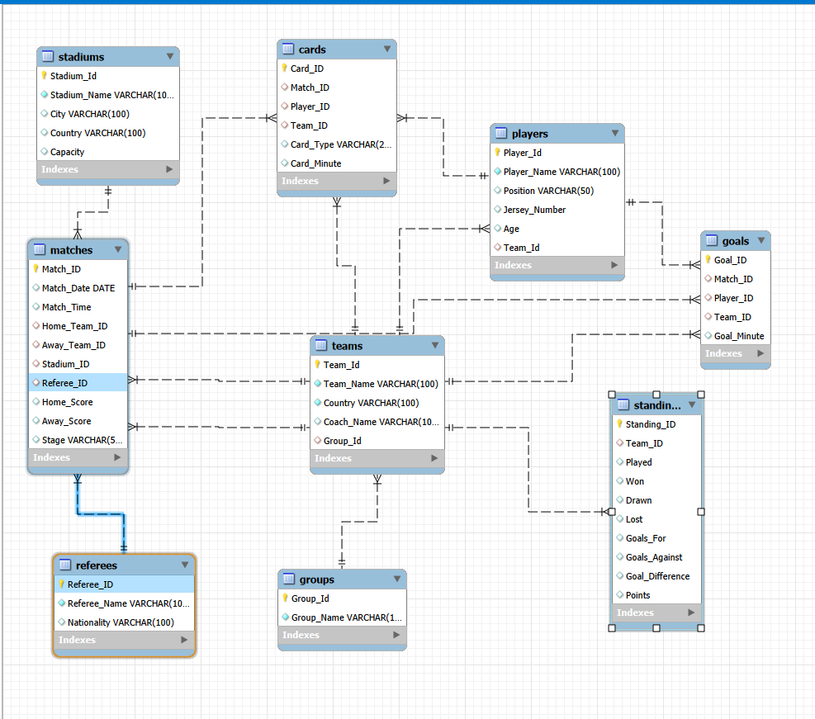

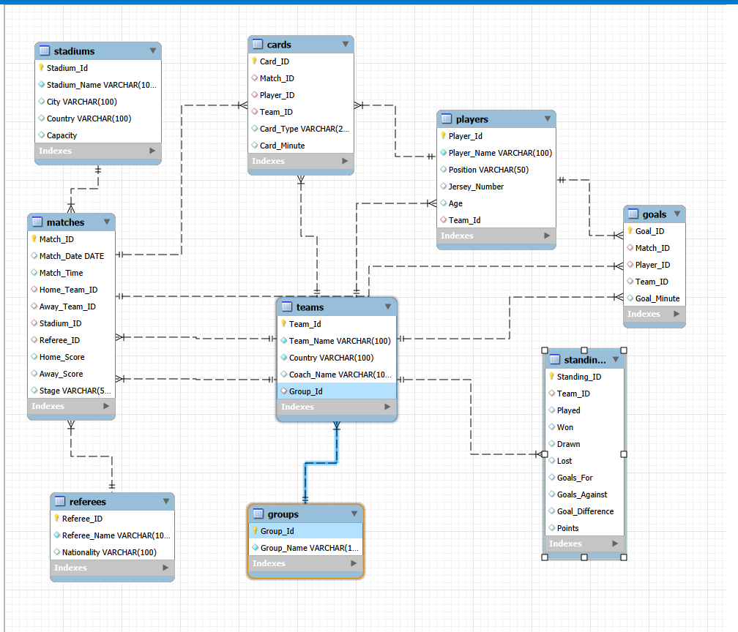

1. Table Descriptions

Groups Table
The groups table stores the tournament groups such as Group A, Group B, and Group C. Each group has a unique group ID and group name.

Main Columns
- Group_Id → unique ID of the group
- Group_Name → name of the group

Teams Table
The teams table stores information about all national teams participating in the tournament.

Main Columns
- Team_Id → unique ID of the team
- Team_Name → team name
- Country → country name
- Coach_Name → team coach
- Group_Id → group of the team

Players Table
The players table stores detailed information about football players.

Main Columns
- Player_Id → unique player ID
- Player_Name → player name
- Position → playing position
- Jersey_Number → shirt number
- Age → player age
- Team_Id → player's team

Stadiums Table
The stadiums table stores information about stadiums used in the World Cup.

Main Columns
- Stadium_Id → stadium ID
- Stadium_Name → stadium name
- City → city name
- Country → country name
- Capacity → stadium capacity

Referees Table
The referees table stores referee information.

Main Columns
- Referee_Id → referee ID
- Referee_Name → referee name
- Nationality → referee nationality

Matches Table
The matches table stores all match information in the tournament.

Main Columns
- Match_Id → match ID
- Match_Date → match date
- Match_Time → match time
- Home_Team_Id → home team
- Away_Team_Id → away team
- Stadium_Id → played stadium
- Referee_Id → referee
- Home_Score → home team score
- Away_Score → away team score
- Stage → tournament stage

Goals Table
The goals table stores all scored goals.

Main Columns
- Goal_Id → goal ID
- Match_Id → match where the goal was scored
- Player_Id → player who scored
- Team_Id → scoring team
- Goal_Minute → minute of the goal

Cards Table
The cards table stores yellow and red cards shown during matches.

Main Columns
- Card_Id → card ID
- Match_Id → related match
- Player_Id → player receiving the card
- Team_Id → player's team
- Card_Type → yellow or red card
- Card_Minute → minute of the card

Standings Table
The standings table stores tournament rankings and statistics.

Main Columns
- Standing_ID → standing ID
- Team_Id → team ID
- Played → matches played
- Won → wins
- Drawn → draws
- Lost → losses
- Goals_For → scored goals
- Goals_Against → conceded goals
- Goal_Difference → goal difference
- Points → total points

2. Primary Key and Foreign Key Relationships

Primary Keys
Primary keys are unique values used to identify each record in a table.
- Group_Id in Groups table
- Team_Id in Teams table
- Player_Id in Players table
- Match_Id in Matches table
Each table has its own primary key.

Foreign Keys
Foreign keys are used to connect tables together.

Main Relationships

Groups → Teams
- Teams.Group_Id
references
- Groups.Group_Id
One group can contain many teams.

Teams → Players
- Players.Team_Id
- references
- Teams.Team_Id
One team can contain many players.

Stadiums → Matches
- Matches.Stadium_Id
references
- Stadiums.Stadium_Id
One stadium can host many matches.

Referees → Matches
- Matches.Referee_Id
references
- Referees.Referee_Id
One referee can manage multiple matches.

Teams → Matches
- Matches.Home_Team_Id
references
- Teams.Team_Id
- Matches.Away_Team_Id
references
- Teams.Team_Id
This relationship connects teams to matches.

Players → Goals
- Goals.Player_Id
references
- Players.Player_Id
One player can score many goals.

Teams → Goals
- Goals.Team_Id
references
- Teams.Team_Id
One team can score many goals.

Players → Cards
- Cards.Player_Id
references
- Players.Player_Id
One player can receive multiple cards.

Teams → Cards
- Cards.Team_Id
references
- Teams.Team_Id
One team can receive multiple cards.

Teams → Standings
- Standings.Team_Id
references
- Teams.Team_Id
Each standings record belongs to one team.

3. ER Diagram Explanation
The ER (Entity Relationship) Diagram shows the visual structure of the database system. It represents the tables, their attributes, and the relationships between them.
In this project, the ER diagram helps explain how the World Cup database is organized.
The main entity of the system is the teams table because many other tables are connected to it.

Important Relationships in the Diagram
- One group contains many teams.
- One team contains many players.
- One stadium hosts many matches.
- One referee controls many matches.
- One player can score many goals.
- One player can receive many cards.
- One team has one standings record.
The diagram also shows the primary keys and foreign keys between tables. These relationships ensure data consistency and improve database organization.
The ER diagram makes the database easier to understand, maintain, and expand in the future.

4. Conclusion
- In conclusion, this project successfully demonstrates the design and implementation of a relational database system for a Football World Cup Organization.

The database system was able to manage teams, players, matches, goals, cards, referees, and standings efficiently using SQL and relational database concepts.

The project improved our understanding of:
- Database design
- Table relationships
- Primary and foreign keys
- SQL queries
- Data management and organization
The system successfully simulated a complete World Cup tournament, including group stage matches, knockout rounds, and the final championship match where Türkiye became the tournament champion.
This project provided practical experience in developing a real-world database application using MySQL.

